Task 1 - Weekly Screen-Time Tracker
D Grade
Initially, the following code block defines users' screen time across three app categories (e.g., Social, Video, Games) as integer values and calculates the total weekly usage time. The code includes a comment line stating 'Daily scroll threshold exceeded' when the daily scrolling limit is exceeded.

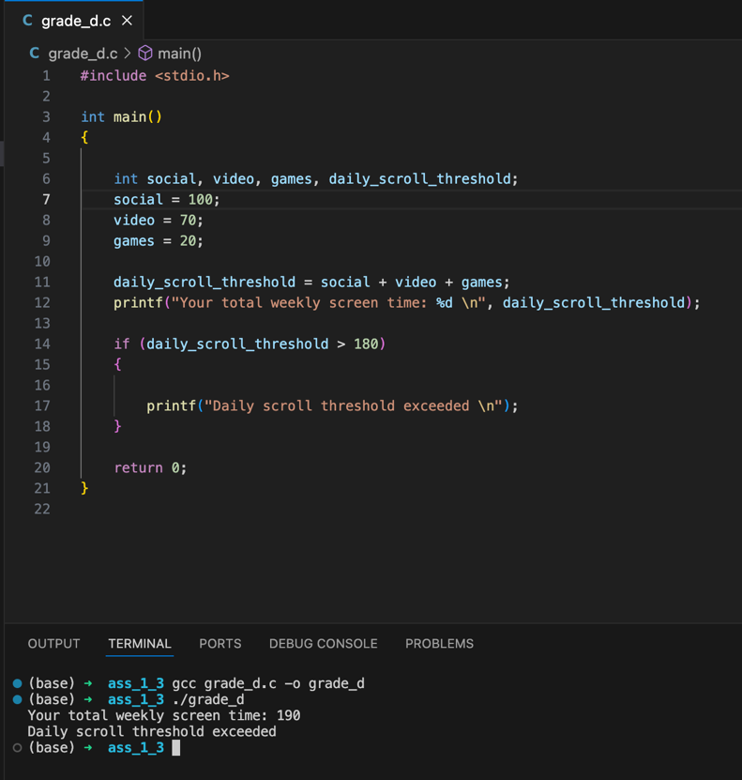
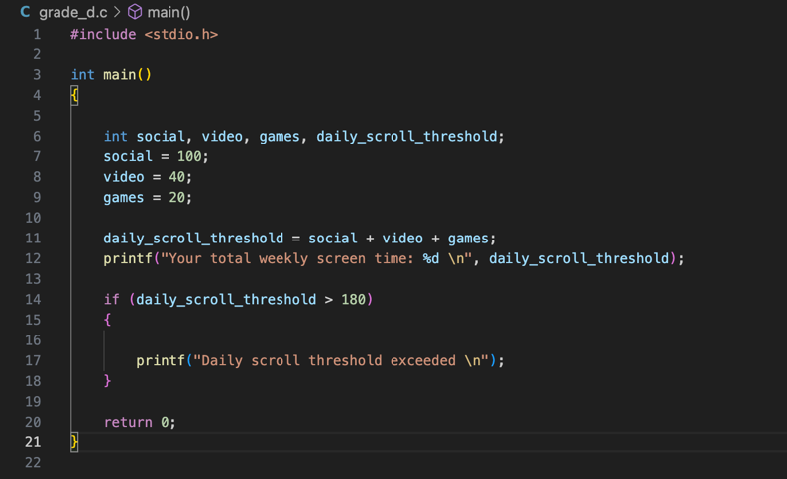
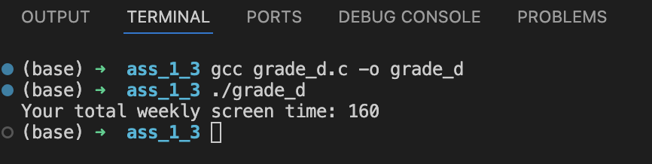

C Grade
In this task, the user will be asked to provide daily screen time data for categories such as Social, Video, and Games. A daily average will be calculated for each category, and this average will be compared to the defined recommended limits. If the user enters a negative value, the program will stop with an error message. This ensures that daily screen usage is monitored.

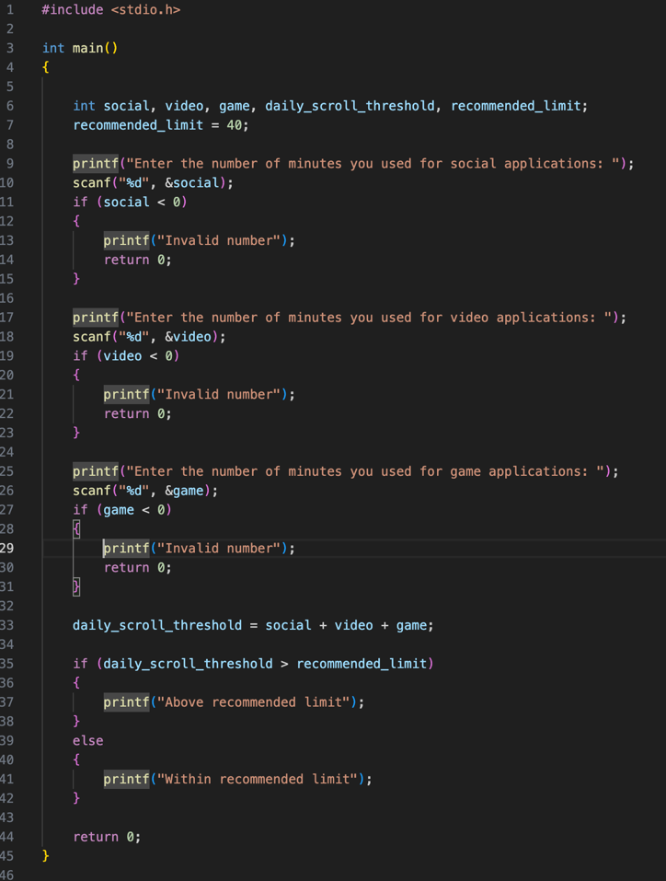
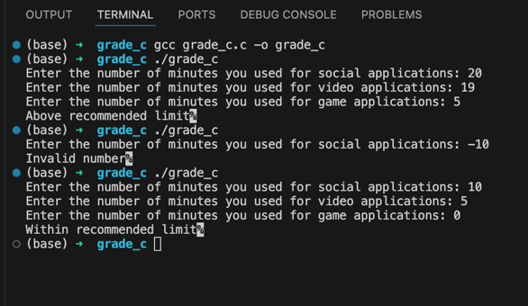

B Grade
In this task, the user will be asked to provide daily screen time data for categories such as Social, Video, and Games. A daily average will be calculated for each category, and this average will be compared to the defined recommended limits. If the user enters a negative value, the program will stop with an error message. This ensures that daily screen usage is monitored.
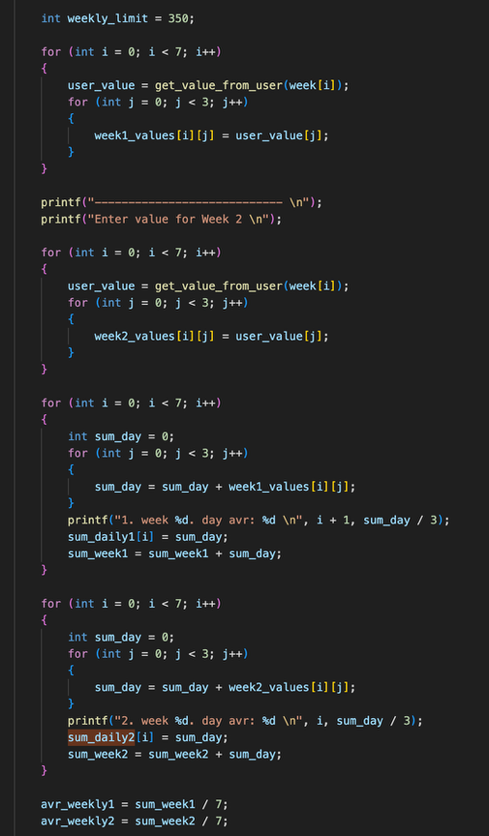
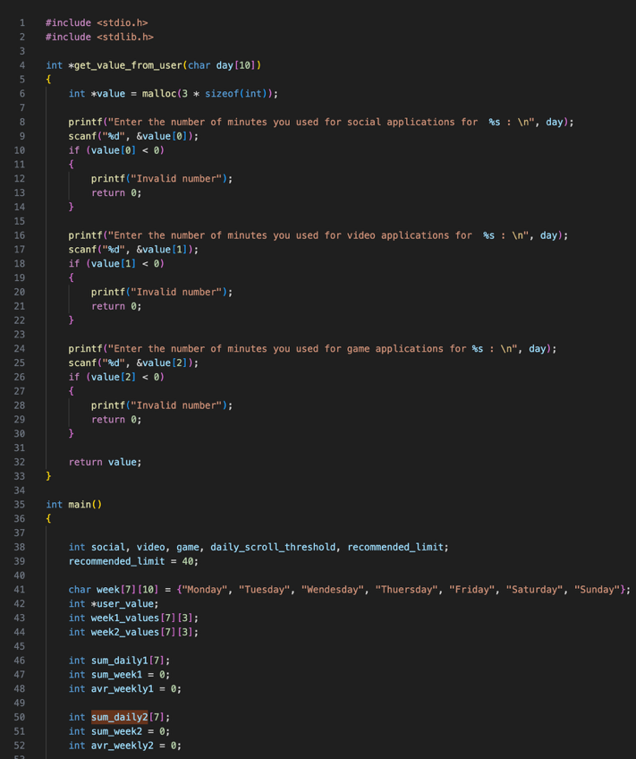

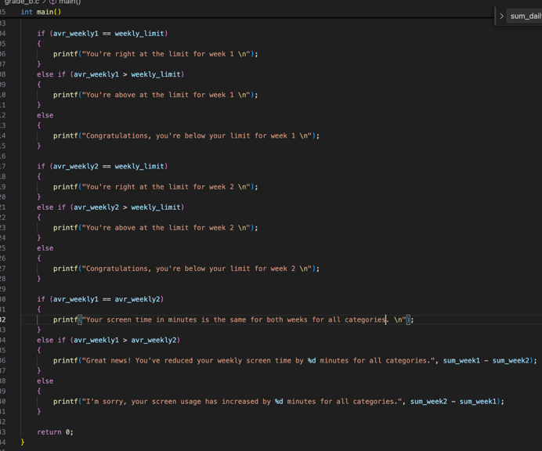
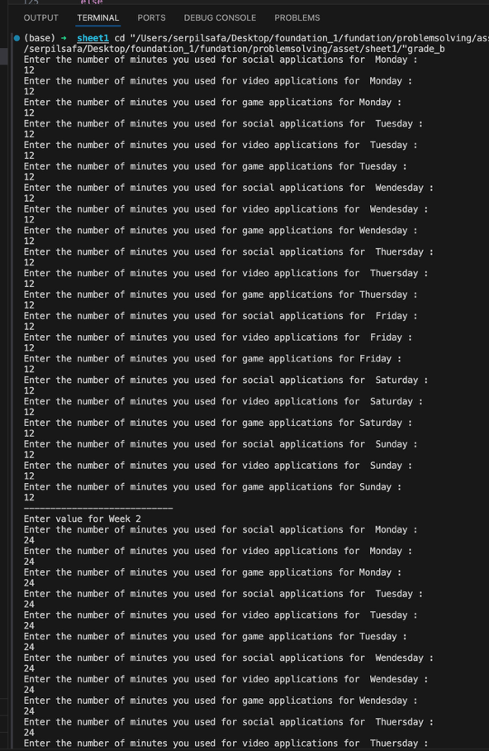

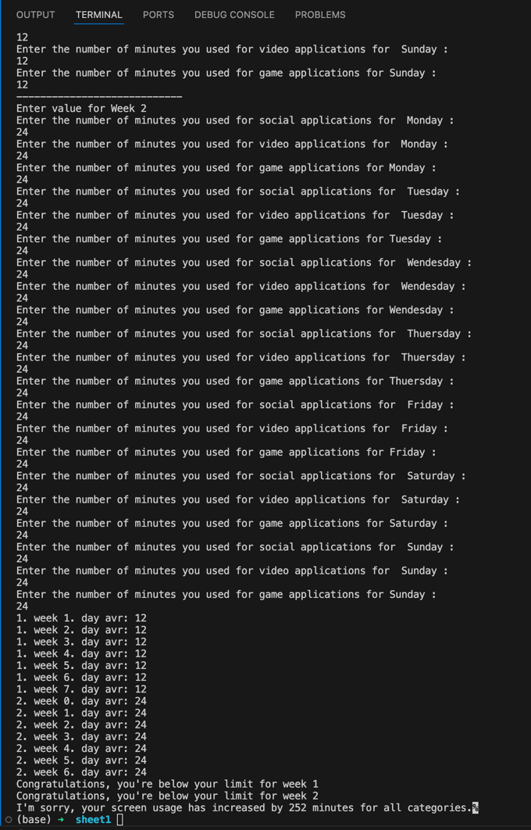

A Grade

The final stage enhances flexibility and analysis capabilities. The user can decide how many categories to use and enter custom category names. Screen time data is collected for each category over a 2-week period. The program provides detailed weekly summaries including category-based breakdowns, total screen time, and daily averages. It also performs a trend analysis for each category, identifying whether usage has increased, decreased, or remained unchanged between the two weeks. A final summary presents overall weekly totals, averages, and category trends.

